MLA Works Cited
2 books & 1 database minimum must be used.

Your textbook does not count as a source.

All images must be cited! You may use google images to find the pictures but be very critical of where you’re getting them from.

http://citationmachine.net

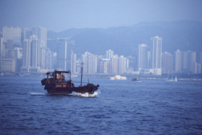

Name of Person
Country They’re From

Your Name
Birth - Death

Describe the achievement with 3 facts in bullet form.
Describe the achievement with 3 facts in bullet form.

Important Facts - Life

Important Facts - Life

Important Facts - Style

1st Achievement

2nd Achievement

3rd Achievement
Describe 2 facts about their life in bullet form
Describe 2 facts about their life in bullet form
Describe the 3 facts about their artistic style in bullet form.
Describe the achievement with 3 facts in bullet form.

